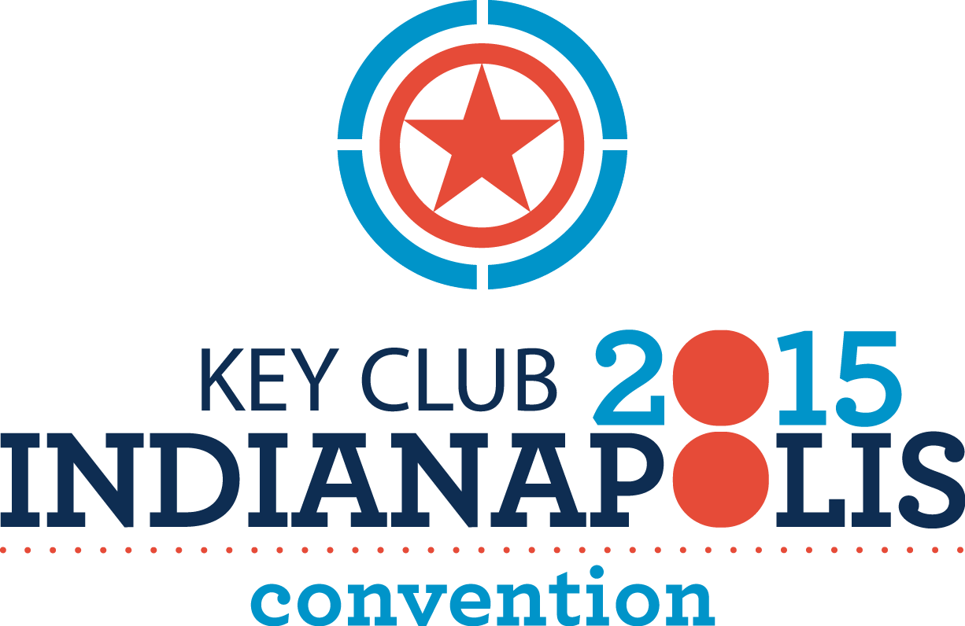

NEW JERSEY DISTRICT OF KEY CLUB
International Convention Primer 2015

Indianapolis, IN
June 23 to June 30, 2015

Imagine this – over 2,000 Key Clubbers from around the world gathered in one room… at the same time….for the same cause. From June 23– June 30, Key clubbers from Districts around the world will come together to celebrate another year of Service to our homes, schools and communities. This year it will take place at the 72nd Annual Key Club International Convention in Indianapolis, IN.

There will always be something to do, whether it is evaluating this year’s candidates for Key Club International office, hearing a motivational speaker or learning more about the phenomenal programs that Key Club International offers, or dancing!!

The New Jersey District of Key Club will be traveling by bus from two locations in New Jersey. The bus will depart in the early morning on June 23rd. After all attendees have boarded the bus, we will travel to Indianapolis, stopping in Hershey, PA and Columbus, Ohio. Attendees will arrive in Indianapolis, IN and attend convention. Attendees will depart Indianapolis, IN on the morning of June 28th. We will stop in Sandusky, Ohio at Cedar Point Amusement Park and in Columbus, Ohio at the Rock and Roll Hall of Fame. Attendees will arrive at two locations in New Jersey on the evening of June 30, 2015.

During our time in Indianapolis, we will stay at the convention hotel, the Indianapolis Marriott Downtown (350 W. Maryland Street, Indianapolis, IN 46265)

The convention will run from June 24-27, 2015. The exact convention schedule will be available at www.keyclub.org shortly.

The package is $1095.00 quad occupancy for students, which includes convention registration fee, transportation, hotels, tours, one dinner meal, and breakfast in our suite while at the convention. Also included are admissions amusement parks and venues we will visit. All other food expenses are your responsibility. The first payment of $600 is due no later than May 8, 2015 to the address below:

Ms. Kaitlin McCann
N. J. District Administrator
83 Harrop Place
Ewing, NJ 08618

Please feel free to contact Ms. McCann at any time if you have any questions or concerns
at 908-902-2452 or kaitlin363@yahoo.com

Below are the costs for the New Jersey District Tour for International Convention June 23 to June 30, 2015

Occupancy | Quad Occupancy  (4 students to a room) | Double Occupancy  (adults only) | Single Occupancy  (Adults only)
Cost | $1095.00 | $1295.00 | $1795.00
First Payment Due  May 8, 2015 | $600.00 | $800.00 | $1100.00
Balance Due June 5, 2015 | $495.00 | $495.00 | $695.00
* Notarized medical forms must be sent in with second payment.

Please fill out the enclosed application and send it along with your first payment made out to the New Jersey District of Key Club by May 8, 2015 to:

Ms. Kaitlin McCann
N. J. District Administrator
83 Harrop Place
Ewing, NJ 08618

New Jersey Key Club Registration Form
International Convention 2015
June 23-30, 2015

*Convention attendees will stay at the assigned convention hotel. Attendees room and travel costs are built into the price of the New Jersey package.

First Name Last Name School Name

Street Address City State Zip Code

Email address (please be neat as this will be used for confirmation) Phone Number

Gender: (Circle One) Male Female ________________________________________
Date of Birth Graduation Year

_______________________________________________________________________________________Position Currently Held in Key Club (Be specific: Club President, District Treasurer, etc)

_______________________________________________________________________________________Dietary Restrictions Allergies

Shirt Size: __________ Adults (Circle One): Single Occupancy Double Occupancy

Please list below the roommates you would like to have. Due to the number of students attending and preferences listed by all attendees, not all requests can be honored. If no roommates are listed, the New Jersey District will match you up with roommates.
- _______________________________
- _______________________________
- _______________________________

Confirmation emails will be sent within one week of when registration and paycheck is received. Email will be sent when the balance of funds is paid. Students will have an additional medical form to complete which will be emailed prior to convention.

Cancellation Policy: All cancellations must be made in writing to Kaitlin McCann at kaitlin363@yahoo.com by May 15th, 2015 to receive a refund. After this date, refunds cannot be guaranteed unless another student of the same gender is able to replace the student who is cancelling.

